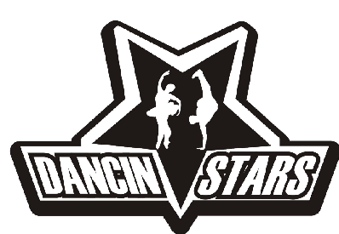
7 – 12 YEAR OLD DANCE CLASSES 2017-2018
Dancin’ Stars – 7757 Edmonds Street, Burnaby, B.C, V3N 1B9
604-524-3516, dancinstarsbc@gmail.com, www.dancinstars.com

Monday:
Beg. Break Dance/Hip Hop Sampler Recital Yoshi Hisanaga (M) 4:00-5:00 pm
Jazz/Lyrical Recital Tamara Dawson (F) 5:00-6:00 pm
Intermediate/Advanced Acro Recital Tamara Burdeny (F) 6:00-7:00 pm
RAD Primary/Grade 1 Ballet Recital Jessie Au (F) 6:00-7:00 pm
Beginner Acro Recital Tamara Burdeny (F) 7:00-8:00 pm
RAD Grade 2-3 Recital Jessie Au (F) 7:00-8:00 pm

Tuesday:
Modern/Contemporary Recital Kennedy Knopf (F) 4:00-5:00 pm
Beginner/Inte. Hip Hop Recital Kyle Vicente (M) 5:00-6:00 pm
Tap Recital Kennedy Knopf (F) 5:00-6:00 pm
Competitive Hip Hop Technique Kyle Vicente (M) 7:00-8:00 pm

Wednesday:
Inter./Adv Hip Hop Recital Matthew Cortez (M) 4:00-5:00 pm
Beg./Int. Jazz Recital Cierra Rohde (F) 5:00-6:00 pm
Hip Hop (6-9) Recital Matthew Cortez (M) 5:00-6:00 pm
Musical Theatre Recital Damon Jang (M) 6:00-7:00 pm
RAD Primary /Grade 1 Ballet Recital Lauren Chen (F) 6:00-7:00 pm
RAD Grade 2/3 Ballet Recital Lauren Chen (F) 7:00-8:00 pm
Bollywood Fusion Recital Karima Essa (F) 7:00-8:00 pm

Thursday:
Hip Hop Recital Kennedy Knoph (F) 3:00-4:00 pm
Street Jazz Recital Samantha Penner (F) 5:00-6:00 pm
Int/Adv Breakdance Technique Yoshi Hisanaga (M) 5:00-6:00 pm
Hip Hop Recital Stewart Iguidez (M) 6:00-7:00 pm
Hip Hop Technique Matthew Cortez (M) 7:00-8:00 pm
Lyrical/Jazz Technique Kennedy Knoph (F) 7:00-8:00 pm
Learn to Battle Technique Yoshi Hisanaga (M) 8:00-9:00 pm

Friday:
Int/Adv. Hip Hop Technique Yoshi Hisanaga (M) 6:00-7:00 pm
Modern/Contemporary Technique Tamara Dawson (F) 7:00-8:00 pm

Sunday:
Hip Hop/Break Dance Sampler Technique Yoshi Hisanaga (M) 12:00-1:00 pm
Beg/Int. Break Dance Recital Yoshi Hisanaga (M) 2:00-3:00 pm
Jazz/Lyrical Recital Samantha Green (F) 2:00-3:00 pm

MUSIC CLASSES
Did you know that Dancin’ Stars offers music lessons? We have qualified instructors in Piano, Guitar and Voice/Singing. For more information please contact us @ 604-524-3516 or email us at dancinstarsbc@gmail.com

