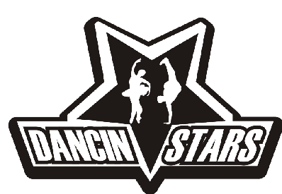

3-6 YEAR OLD DANCE CLASSES 2017-2018
Dancin’Stars – 7757 Edmonds Street, Burnaby, B.C, V3N 1B9
604-524-3516, dancinstarsbc@gmail.com www.dancinstars.com

Monday:
Acro (4-6) Recital Tamara Burdeny (F) 4:00-5:00 pm
Preschool Ballet Recital Jessie Au (F) 5:00-6:00 pm
Hip Hop Recital Tamara Dawson (F) 6:00-7:00 pm
RAD Primary/Grade 1 Ballet Recital Jessie Au (F) 6:00-7:00 pm
RAD Grade 2/3 Ballet Recital Jessie Au (F) 7:00-8:00 pm

Tuesday:
Tap Recital Kennedy Knopf (F) 5:00-6:00 pm
Wednesday:
Musical Theatre Recital Damon Jang (M) 4:00-5:00 pm
Hip Hop (6-9) Recital Matthew Cortez (M) 5:00-6:00 pm
RAD Preschool Ballet Recital Lauren Chen (F) 5:00-6:00 pm
Bollywood Fusion Recital Karima Essa (F) 5:00-6:00 pm
Jazz Recital Cierra Rohde (F) 6:00-7:00 pm
RAD Primary/Grade 1 Ballet Recital Lauren Chen (F) 6:00-7:00 pm
RAD Grade 2/3 Ballet Recital Lauren Chen (F) 7:00-8:00 pm

Thursday:
Jazz Recital Kennedy Knopf (F) 4:00-5:00 pm
Street Jazz Recital Samantha Penner (F) 6:00-7:00 pm
Learn to Battle(6y/o & up) Technique Yoshi Hisanaga (M) 8:00-9:00 pm

Sunday:
Hip Hop Recital Samantha Green (F) 11:00-12:00 pm
Hip Hop/Break Sampler(6y/o & up) Technique Yoshi Hisanaga (M) 12:00-1:00 pm

MUSIC CLASSES
Did you know that Dancin’ Stars offers music lessons? We have qualified instructors in Piano, Guitar and Voice/Singing. For more information please contact us @ 604-524-3516 or email us at dancinstarsbc@gmail.com

